**EXPERIMENT – 1**

**Aim of the experiment** :- **Write a program to install pandas and using it.**

**Code :-**

**!pip install pandas --upgrade –quiet**

**import pandas as pd**

**OUTPUT:-**



**Conclusion :-**By doing above experiment we successfully install pandas.

**EXPERIMENT – 2**

**Aim of the experiment** :- **Write a program to**  **create a dataframe using two-dimensional List.**

**Code :-**

import pandas as pd

lst = [['tom', 'reacher', 25], ['krish', 'pete', 30],

       ['nick', 'wilson', 26], ['juli', 'williams', 22]]

df = pd.DataFrame(lst, columns =['FName', 'LName', 'Age'],

                                           dtype = float)

print(df)

OUTPUT:-

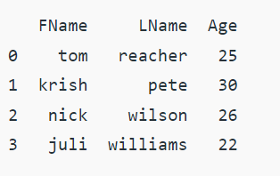

**Conclusion :-**By doing above experiment we successfullycreate a dataframe using two-dimensional List.

**EXPERIMENT – 3**

# Aim of the experiment :- Write a program to Creating DataFrame from dict of narray/lists

***Code :-***

**# Python code demonstrate creating**

**# DataFrame from dict narray / lists**

**# By default addresses.**

**import pandas as pd**

**# initialise data of lists.**

**data = {'Category':['Array', 'Stack', 'Queue'],**

**'Marks':[20, 21, 19]}**

**# Create DataFrame**

**df = pd.DataFrame(data)**

**# Print the output.**

**print(df )**

***OUTPUT:-***

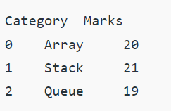

# Conclusion :-By doing above experiment we successfully create a Creating DataFrame from dict of narray/lists

**EXPERIMENT – 4**

# Aim of the experiment :- Write a program Creating DataFrame using multi-dimensional list

***CODE:-***

***# import pandas as pd***

***import pandas as pd***

***# List1***

***lst = [['tom', 25], ['krish', 30],***

***['nick', 26], ['juli', 22]]***

***df = pd.DataFrame(lst, columns =['Name', 'Age'])***

***df***

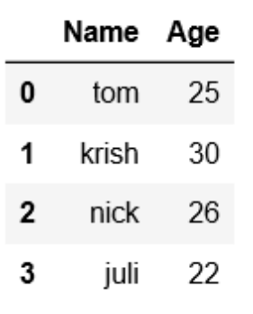***OUTPUT:-***

# Conclusion :-By doing above experiment we successfully Creating DataFrame using multi-dimensional list

**EXPERIMENT – 5**

# Aim of the experiment :- Write a program OF Reading CSV files in Python.

***CODE:-***

***import pandas***

***# reading the CSV file***

***csvFile = pandas.read_csv('Giants.csv')***

***# displaying the contents of the CSV file***

***print(csvFile)***

***OUTPUT:-***

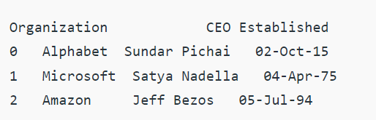

# Conclusion :-By doing above experiment we successfully Reading CSV files in Python.

**EXPERIMENT – 6**

# Aim of the experiment :- Write a program OF Creating Pandas dataframe using list of lists

***CODE:-***

***# Import pandas library***

***import pandas as pd***

***# initialize list of lists***

***data = [[1, 5, 10], [2, 6, 9], [3, 7, 8]]***

***# Create the pandas DataFrame***

***df = pd.DataFrame(data)***

***# specifying column names***

***df.columns = ['Col_1', 'Col_2', 'Col_3']***

***# print dataframe.***

***print(df, "\n")***

***# transpose of dataframe***

***df = df.transpose()***

***print("Transpose of above dataframe is-\n", df)***

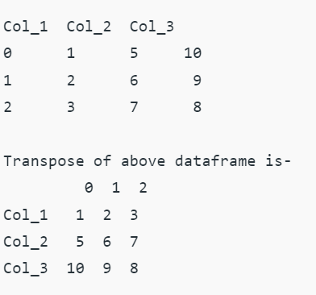***OUTPUT:-***

# Conclusion :-By doing above experiment we successfully Creating Pandas dataframe using list of lists.

**EXPERIMENT – 7**

# Aim of the experiment :- Write a program to Create a Pandas DataFrame from Lists

***CODE:-***

***# import pandas as pd***

***import pandas as pd***

***# List1***

***lst = [['tom', 'reacher', 25], ['krish', 'pete', 30],***

***['nick', 'wilson', 26], ['juli', 'williams', 22]]***

***df = pd.DataFrame(lst, columns =['FName', 'LName', 'Age'], dtype = float)***

***df***

***output***

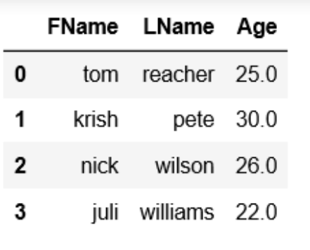

# Conclusion :-By doing above experiment we successfully Creating Pandas dataframe from list.

**EXPERIMENT – 8:-**

# Aim of the experiment :- Write a program to Creating a Pandas dataframe using list of tuples

**Code :-**

**# import pandas to use pandas DataFrame**

**import pandas as pd**

**# data in the form of list of tuples**

**data = [('Peter', 18, 7),**

**('Riff', 15, 6),**

**('John', 17, 8),**

**('Michel', 18, 7),**

**('Sheli', 17, 5) ]**

**# create DataFrame using data**

**df = pd.DataFrame(data, columns =['Name', 'Age', 'Score'])**

**print(df)**

**OUTPUT**

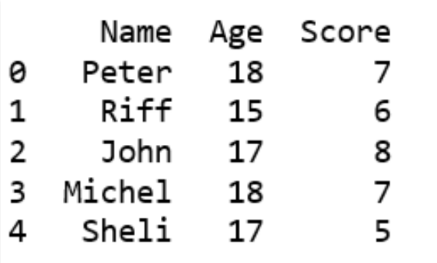

# Conclusion :-By doing above experiment we successfully to Creating a Pandas dataframe using list of tuples.

**EXPERIMENT – 9:-**

# Aim of the experiment :- Write a program to Create a Pandas DataFrame from List of Dicts.

**Code :-**

**# Python code demonstrate how to create**

**# Pandas DataFrame by lists of dicts.**

**import pandas as pd**

**# Initialise data to lists.**

**data = [{'Geeks': 'dataframe', 'For': 'using', 'geeks': 'list'},**

**{'Geeks':10, 'For': 20, 'geeks': 30}]**

**# Creates DataFrame.**

**df = pd.DataFrame(data)**

**# Print the data**

**Df**

**OUTPUT:-**

# 

# Conclusion :-By doing above experiment we successfully to Create a Pandas DataFrame from List of Dicts.

**EXPERIMENT – 10:-**

# Aim of the experiment :- Write a program to Adding dict values to rows.

# Code :-

# # rows list initialization

# rows = []

# # appending rows

# for data in list:

# data_row = data['Student']

# time = data['Name']

# for row in data_row:

# row['Name']= time

# rows.append(row)

# # using data frame

# df = pd.DataFrame(rows)

# # print(df)

**OUTPUT**

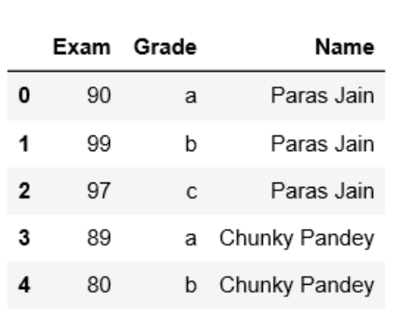

# Conclusion :-By doing above experiment we successfully to Adding dict values to rows.

**EXPERIMENT – 11:-**

# Aim of the experiment :- Write a program to Replace values in Pandas dataframe.

# Code :-

# # importing pandas as pd

# import pandas as pd

# # Let's create a Dataframe

# df = pd.DataFrame({'City':['New York (City)', 'Parague', 'New Delhi (Delhi)', 'Venice', 'new Orleans'],

# 'Event':['Music', 'Poetry', 'Theatre', 'Comedy', 'Tech_Summit'],

# 'Cost':[10000, 5000, 15000, 2000, 12000]})

# # Let's create the index

# index_ = [pd.Period('02-2018'), pd.Period('04-2018'),

# pd.Period('06-2018'), pd.Period('10-2018'), pd.Period('12-2018')]

# # Set the index

# df.index = index_

# # Let's print the dataframe

# print(df)

***OUTPUT:-***

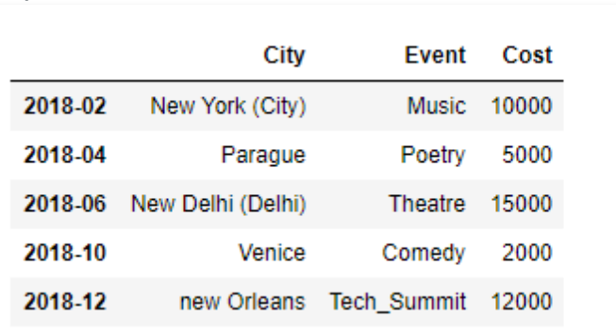

# Conclusion :-By doing above experiment we successfully Replace values in Pandas dataframe.

**EXPERIMENT – 12:-**

# Aim of the experiment :- Write a program to Merging data from multiple sources

# Code :-

# urlretrieve('https://gist.githubusercontent.com/aakashns/8684589ef4f266116cdce023377fc9c8/raw/99ce3826b2a9d1e6d0bde7e9e559fc8b6e9ac88b/locations.csv',

# 'locations.csv')

# locations_df = pd.read_csv('locations.csv')

# locations_df

# OUTPUT:-

# 

# Conclusion :-By doing above experiment we successfully Merging data from multiple sources.

**EXPERIMENT – 13:-**

# Aim of the experiment :- Write a program to Basic Plotting with Pandas.

# Code :-

# result_df.to_csv('results.csv', index=None)

# result_df.new_cases.plot();

# OUTPUT:-

# 

***CODE:-***

***result_df.new_cases.plot()***

***result_df.new_deaths.plot();***

***OUTPUT:-***

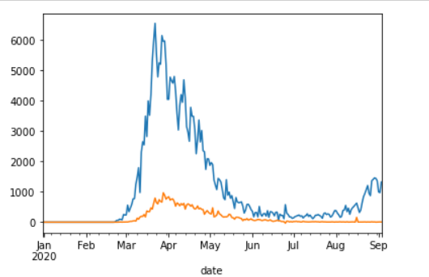

# Conclusion :-By doing above experiment we successfully Basic Plotting with Pandas.